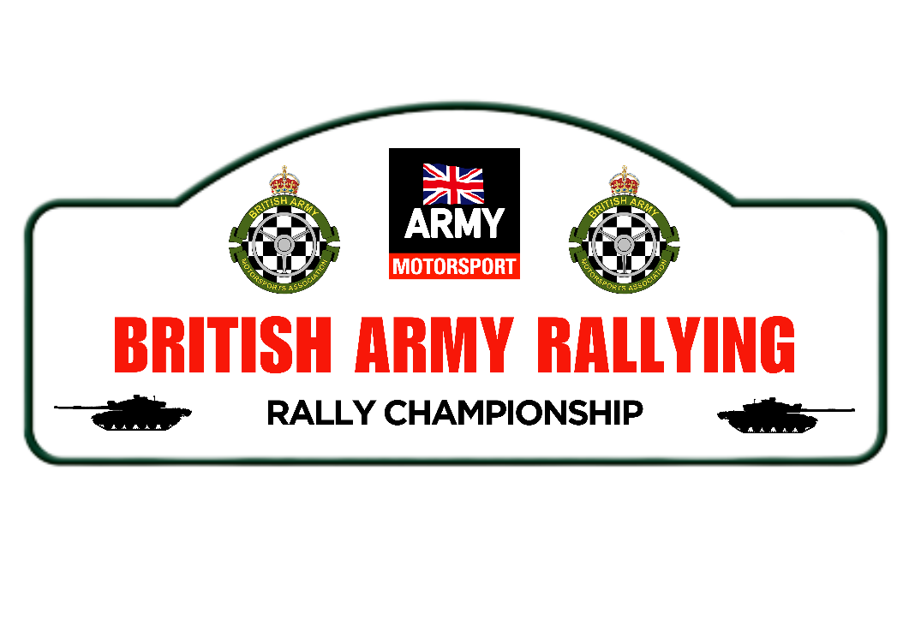
Version 1.1 – 04 Jan 2024

Aims
The 2024 British Army Motorsports Association (BAMA), British Army Rallying (BAR) Championship will be promoted and run by BAMA who are the permit holders. Sgt J Quintrell will co-ordinate the Championship on behalf of BAMA. The aims of the Championship are 3-fold:
- Promote motor sport within the ARMY by providing an effective entry level opportunity into rallying for new BAMA members but concurrently enabling experienced BAMA members to compete at a challenging level subject to the commitments of the Service.
- Facilitate the development of our novices by providing a simple format where they can practice their race-craft, car development skills and benefit from the guidance of our more experienced competitors.
- By rewarding performance rather than finishing position, encourage innovative car preparation, develop team building, good relations with fellow competitors and provide development, training, and support to enable competitors to contest the Championship at a sustainable cost proportionate to ARMY remuneration scales.
Section 1 – General
1.1 The permit holder for the BAR Championship will be BAMA. Permit Numbers reg no. 120733.
1.2 The Championship will be organised in accordance with the General Regulations of the Motor Sport UK (incorporating the provisions of the International Sporting Code of the FIA), these Regulations and any subsequent organizers’ bulletins.
1.3 Motorsport UK (MSUK) Permit No 120733
1.4 The Championship is open to anyone who is a member of BAMA and holds a stage rally licence as a driver or co-driver. The organisers have the right to refuse the registration of anyone and to exclude any registered competitor if need be.
1.5 While it is understood that there will be a high level of competitiveness on the stages, competitors must have a fun and fair-minded approach to the sport. At all times the excellent reputation of the ARMY must be maintained, and all competitors are to always act in line with the spirit of service and ethos of the ARMY.
1.6 All protests in respect of these Regulations must be lodged in accordance with the General Regulations of MSUK.
1.7 Changes or additions to these regulations will be communicated through various channels such as by post and email. Competitors are encouraged to keep in good contact with the Organisers and to regularly monitor the BAMA Website and Forum to ensure they stay current with any issues. Changes or additions to the Regulations after initial MSUK sanction must be approved by a vote and agreed by registered competitors. This vote can only be initiated by the Championship coordinators.
1.8 All competitors must register as detailed in Section 4 below. Registration for the Championship does not guarantee a right of entry on any of the qualifying events.
Section 2 – BAMA British Army Rallying Championship Officials
2.1 Officials for the Championship are:
Championship Organiser: Sgt J Quintrell.
Championship Organiser 2 I/C: WO2 (CSM) B De-Ronde
Competitor Liaison: WO2 (CSM) B De-Ronde.
Championship Secretary: Sgt J Quintrell
Sponsorship Officer: Sgt S Machin
Social Media Officer: LCpl A Merrifield supported by all
Scrutineer: As no technical regulations apply to this Championship all scrutineering will be conducted by the on-event scrutineering team.
Stewards: Maj M Saunders, Maj C Allford.
2.2 The Championship Officials will be Judges of Fact regarding the implementation of these Regulations.
Section 3 – Classes
3.1 The Championship does not require a class structure due to the scoring system used. All competitors will enter a class in line with the individual event organiser’s regulations and MSUK rules.
Section 4 – Registration
4.1 To register for the Championship competitors must complete a 2024 Championship Registration Form. There is no charge to enter the Championship.
4.2 Registration Forms are available from the BAMA, Rally Championship website or directly from the Championship Organisers. Registration Forms must be returned by email or hand delivered, unless agreed otherwise by the Organisers. Drivers and co-drivers must be registered to be able to score points in the Championship. Exceptions will only be made by prior agreement.
4.3 Registered competitors should note that the information they supply will be held in a computerised database for the purpose of producing mailing lists and recording results. This information may also be used for other purposes to do with the Championship.
Section 5 - Qualifying Events
5.1 The Championship will consist of 5 rounds all of which will count for Championship points. Due to the dispersed nature of ARMY Personnel, it is difficult to identify 5 suitable events to accommodate for the geographic restrictions of Service life. To facilitate a collective Championship, registered competitors will identify an event within a specified time period; to which the collective results will be identified as a round. Round 5 will be a non-selectable, mandatory round to provide a natural focus and shared event for the Championship.
5.2 The following Rounds will make up the 2024 British Army Rallying ￼:
Round 1 – Any event held between 1 Jan and 30 Jun inclusive
Round 2 - Any event held between 1 Mar and 31 Aug inclusive
Round 3 - Any event held between 1 May and 31 Oct inclusive
Round 4 - Any event held between 1 July and 31 Dec inclusive
Round 5 – Date TBC, Coningham Cup
5.3 Competitors under exceptional circumstances and with prior notice may adjust round periods but that will only be with adjacent rounds and due to strict service requirements only. This must be discussed and confirmed in advance with the Championship organisers.
5.4 It should be noted that the Championship organisers are not responsible for the final results awarded to competitors on events. Event results are solely the decision of the individual event organisers. However, it will be the results of the event that will be used by the Championship organisers to determine for the standings in the Championship.
5.5 Competitors are free to select any event, and no points weighting will be given to surface type, event status, single/multi venue or any other variable. This allows for novices and experienced competitors to choose events best suited for their individual financial/geographical considerations and skill levels. If it is felt by the Organisers that this process is being abused, then action may be taken in line with Section 8.
5.6 Competitors can attempt as many events in an identified Round period as they wish however only the pre-identified event will be counted. Competitors cannot complete several events in a designated period and then select their best score as the Round score.
5.7 Cancelled events may be replaced for any other event within the identified Round time limits. In the event of an individual rally being cancelled and their being no other event available within the allocated round period then specific guidance will be given by the Championship Organisers. Please contact the Championship Comp Sec or the Championship Organiser in the first instance.
Section 6 - The Cars
6.1 Any car is eligible for the Championship provided it meets the competition and safety regulations as detailed by the MSUK Blue Book 2024.
6.2 All competing cars must prominently display the decals of the BAMA Army Rally Championship, ARMY Motorsports and Championship sponsors.
Section 7 - Point Scoring
7.1 Points will be awarded to registered drivers and co-drivers on each qualifying event. Two Championships will be run concurrently, one for Stage Rally and the second for Targa Rally.
7.2 At the year end, awards will be given out to first overall, driver and co-driver.
7.3 The Annual Awards will be presented at a prize giving ceremony or Prize Giving Dinner: dates to be advised in a later bulletin.
7.4 The allocation of any additional prizes - cash or goods or services - will be at the discretion of the Championship Organisers.
7.5 Should any event fail to run the Championship Organisers may select a similar event to substitute. If it proves not possible to replace events the final positions will be decided from the completion of the remaining events, depending on how many events are run. Each event will be scored on the following basis which is based on a system involving total number of crews in class.
7.6 Points are awarded for each event as follows:
Starting Round 1-4: 10 points
Starting Round 5: 30 points
Finishing Rounds 1-5: 20 points
Participating as Registered Marshall/MSUK Official on event: 30 points per event
Plus, percentage of starters in class beaten. (Fractions rounded to nearest whole number with halves rounded up)
Example: Finishing 4th in class on the final event with 18 starters in class
30 points for starting
Number beaten in class = 14 (18 – 4)
% beaten in class = 14/18 x 100 = 78
20 points for finishing
Points awarded = 30+78+20 =128
7.7 Points can only be scored against the class entered and competed in. If the rally organisers combine classes, the combined class will be considered a single class in respect of points. No finishing points are awarded for restarts in practice rallies or “super” rallies.
7.8 Championship competitors participating in the 2024 ARMY Motorsport Day (AMD) will be awarded 50 points. Championship competitors participating in any 2024 BAR organised training events will be awarded 20 points.
7.9 Event results will be made available by the event organisers, all competitors must submit their results to the Championship Secretary by email within 14 days of the event. Event media is to be submitted by competitors to the Social Media Officer no later than 14 days after the start day of the event. It is the competitor’s responsibility to submit images and text to the Media Officer after each event, or to upload their own story to the Championship Social Media. Any points scored will be listed as provisional until this has been completed and submitted. Failure to complete submission within 14 days will result in a forfeiture of all points gained at that respective event. This will be strictly enforced for 2024.
a. Exceptional circumstances may be discussed with the Championship Secretary prior to the deadline. It is also the competitor’s responsibility to check after each event that the points allocated are correct.
b. All social media updates must be first placed onto the BAR Championship Social media platforms prior to being placed on other BAMA/Corp Team platforms. Failure to manage this could result in your points being removed.
Section 8 - Eligibility, Penalties and Appeals
8.1 Any appeals must be lodged in accordance with Section C of the MSUK Yearbook. Registered competitors are reminded of the requirements of Section C6.5 regarding the time limits for lodging appeals.
8.2 Any breach of these Regulations can result in the loss of points or exclusion.
8.3 If the Championship is curtailed for any reason [e.g., foot and mouth disease], including war, acts of God etc, then the Championship may be declared final to the last complete round.
Section 9 - Disputes
9.1 Any ties will be decided in favour of the competitor with the greatest number of highest event scores (Round wins). In the event of a further tie the greatest number of second highest event scores shall decide and so on. If this fails to resolve the tie, then joint awards will be presented.
9.2 In the event of a dispute that cannot be resolved by the Championship Organisers, the matter will be initially referred to the BAMA Executive Committee (EC) (Chairman, Deputy Chairman, Treasurer & Secretary). Any EC member with an interest (e.g., as a competitor) will abstain and the decision of the EC will be final. Please note the MSUK retains primacy over regulating motorsport and as such recourse to the MSUK maybe the only option under some circumstances.

Events must be an MSUK registered and approved Special Stage or Targa Rally. No other type of event will eligible.
Round 5 is a mandatory event. It must be attended by all personnel that are available. No crew will be able to score points at an alternate event that clashes with the Organisers nominated Round 5 (unless in receipt of express permission by the Organiser).
This is the aspiration, competitors following recognised Championships will be able to score on those rounds if registered with BAR and given permission by the Organiser.
See note 1.
The UK AFRT are not able to enter the BAR Championship.
You can only score these against the principal Championship you are registered for, either Stage or Targa Rally.
Personal updates are acceptable. Post on alternate BAMA pages are not.
Notwithstanding the primacy of the MSUK as exercised under Section 8.1 of these Regulations.

